**Project Identification**

| **Project:** | 12133 |
| --- | --- |
| **Prepared By:** | Kym Michael Gripal, Mustafa Izci, Omar Nabi, Reyansh Srivastava, Arshpreet Kaur |
| **Document Version:** | 1.0 |
| **Published Date:** | October 2, 2022 |

**Contributors**

*The following individuals contributed to this document.*

| **Name** | **Title** |
| --- | --- |
| Kym Michael Gripal | DevOps Engineer |
| Mustafa Izci | Full stack Engineer |
| Omar Nabi | Full stack Engineer |
| Reyansh Srivastava | Full stack Engineer |
| Arshpreet Kaur | Full stack Engineer |

**Distribution**

*This document is distributed to all the following people.*

| **Name** | **Title** |
| --- | --- |
| Anjana Shah | Program Coordinator |

**Referenced Documents**

*This document refers to the following materials*

| **Version number** | **Title** | **Author** | **Date** | **Source / Location** |
| --- | --- | --- | --- | --- |
| *4.0* | HOPE Vision | *Team Crutch* | *November 29, 2010* | https://studylib.net/doc/7575238/hope-vision |

**Revision History**

| **Version Number** | **Revision Date** | **Summary of Changes** | **Modified by** |
| --- | --- | --- | --- |
| *0.1* | September 26, 2022 | Initial Draft | Kym Michael Gripal  Omar Nabi  Arshpreet Kaur  Reyansh Srivastava  Mustafa Izci |
| *0.2* | September 27, 2022 | Minor Changes | Kym Michael Gripal  Omar Nabi  Arshpreet Kaur  Reyansh Srivastava  Mustafa Izci |
| 0.3 | September 29, 2022 | Added Diagram | Kym Michael Gripal  Omar Nabi  Arshpreet Kaur  Reyansh Srivastava  Mustafa Izci |
| 0.4 | October 1, 2022 | Added scope statements | Kym Michael Gripal  Omar Nabi  Arshpreet Kaur  Reyansh Srivastava  Mustafa Izci |
| 1.0 | October 2, 2022 | Final revisions and grammar checks | Kym Michael Gripal  Omar Nabi  Arshpreet Kaur  Reyansh Srivastava  Mustafa Izci |

**TABLE OF CONTENTS**

***1.*** ***BUSINESS CONTEXT DIAGRAM 3***

***2.*** ***REQUIREMENTS SCOPE STATEMENTS 4***

***3.*** ***HIGH LEVEL BUSINESS REQUIREMENTS (HLR) TRACEABILITY 4***

***4.*** ***HIGH LEVEL BUSINESS REQUIREMENTS SIGN-OFF 4***

1. **Business Context Diagram**

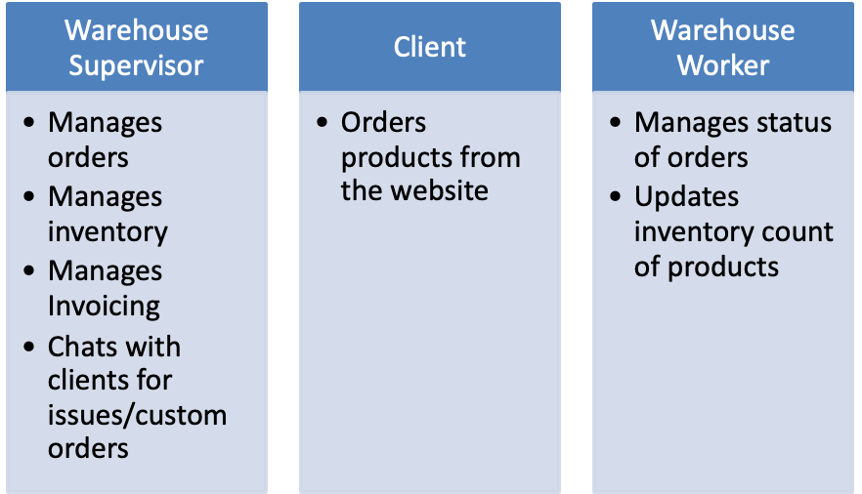

| **Requirement Scope Area** | **Description** |
| --- | --- |
| CB Orders | CB Orders is a web-based application that automates the procurement process for CB. This will include a clean e-commerce interface for the clients, a Kanban-style graphical user interface (UI) for the workers, a robust database storing all inventory information of the departments and the ability to generate invoices for the clients. |

| **External Entity** | **Description** |
| --- | --- |
| Warehouse worker | Has the ability to manage order using the web application’s Kanban user interface. |
| Warehouse supervisor | Has access to the inventory and order management, has access to chat functions to clients. |
| Administrator | Maintains the application and provide software support |
| Accountant | Access finished orders and generates invoices |
| Clients | Makes purchases using the web application’s user interface |

| **Information Flows** | **Description** |
| --- | --- |
| Order management | Ability for warehouse workers to search, filter and update the status of orders using the user interface of the web application, ability of the warehouse supervisor to update the details of the orders as well as manually add and cancel the orders |
| eCommerce website | Clients can purchase products using the eCommerce portion of the web application |
| Inventory Management | Ability of the warehouse supervisor to update the inventory in accordance with the available inventory of the store |
| Invoice Generation | Ability of the application to generate invoices to be sent to the accounting department, the client, and the warehouse supervisor |
| Text chat | Ability for the clients to quickly connect to the warehouse supervisor for any issues or custom orders. |

1. **Requirements Scope Statements**

| **HLR#** | **Description** | **Priority**  **(H, M, L)** |
| --- | --- | --- |
|  | Clients will be able to shop for products | H |
|  | Clients will be able to put products in a shopping cart | H |
|  | Clients will be receiving status updates for the orders | H |
| HLR04 | Warehouse worker will be able to see all orders | H |
| HLR05 | Warehouse worker will be able to search and filter orders | H |
| HLR06 | Warehouse Worker will be able to update the status of each order | H |
| HLR07 | Warehouse worker will be able to update the count of inventory of each product | M |
| HLR08 | Warehouse supervisor will be able to manage all orders | H |
| HLR09 | Warehouse supervisor will be able to manage available inventory | H |
| HLR10 | Warehouse supervisor will be able to chat with clients via text chat | M |
| HLR11 | Warehouse supervisor will be able to manage warehouse worker accounts | M |

1. **High Level Business Requirements Sign-Off**

*The undersigned acknowledge their agreement with the contents of Version 1.0 of the* High-Level *Requirements document for CB Orders*.

*Following approval of this document, requirements changes will be governed by the project’s change management process, including impact analysis and appropriate reviews and approvals, under the general control of the Project Plan and according to company policy. Approved Change Request Documents, if present, will be attached to this Requirements Document as updates.*

| **Name** | **Project Role and**  **Functional Area** | **Date Signed** |
| --- | --- | --- |
| Kym Michael Gripal | DevOps Engineer | October 2, 2022 |
| Mustafa Izci | Full stack Engineer | October 2, 2022 |
| Omar Nabi | Full stack Engineer | October 2, 2022 |
| Arshpreet Kaur | Full stack Engineer | October 2, 2022 |
| Reyansh Srivastava | Full stack Engineer | October 2, 2022 |

*\* Note: physical signatures are not required. Email approvals are acceptable and should be appended to project documents.*